**Project Design Phase-I** - **Solution Fit**

**Project Title: NEWS TRACKER APPLICATION Team ID:** PNT2022TMID49399

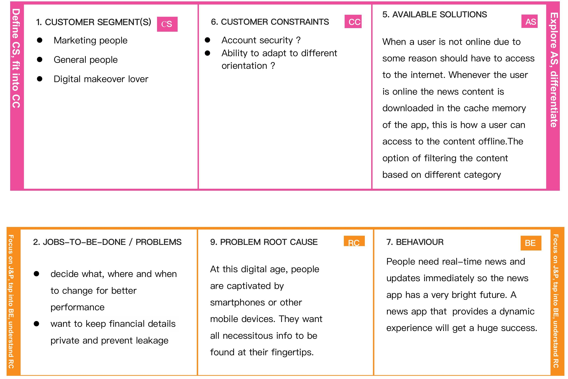**E**

**D**

**x**

**e p**

**fi l**

**n o**

**e r**

**F o c u s**

**o n J**

|  |  |  |  |  |  |  |  |
| --- | --- | --- | --- | --- | --- | --- | --- |
|  | |  | | --- | | **TR** |   **3. TRIGGERS**  News app triggers to describe automatically specific news or event faster and more targeted | |  | | --- | | **SL** |   **10. YOUR SOLUTION**  Evident that [developing](https://www.mindinventory.com/blog/newspaper-app-development-features-cost-estimation/) [a](https://www.mindinventory.com/blog/newspaper-app-development-features-cost-estimation/) [news](https://www.mindinventory.com/blog/newspaper-app-development-features-cost-estimation/) [app](https://www.mindinventory.com/blog/newspaper-app-development-features-cost-estimation/) helps you stand out among all competitors. The aforesaid aspects let a news app promote an online magazine and as a result, the app reaches out and attracts many people from all across the world. | |  | | --- | | **CH** |   **8.CHANNELS of BEHAVIOUR**  **8.1 ONLINE**  **User can access all kind of news in many forms**  **8.2 OFFLINE**  User can view news in offline mode |  |
| |  | | --- | | **EM** |   **4. EMOTIONS: BEFORE / AFTER**  Before - User can’t get news up to date and wont be able to react to those news  After - User can post their comments and find  categories and individual articles |